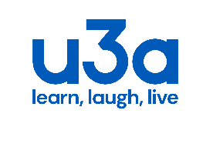
u3a Dumfries
Charity number SC021683
Charity Gift Aid Declaration – multiple donation
Gift Aid is reclaimed by the charity from the tax you pay for the current tax year.
Your address is needed to identify you as a current UK taxpayer.
In order to Gift Aid your donation you agree that
You want to Gift Aid a donation of £12 and any donations you make in the future to u3a Dumfries
You are a UK taxpayer and understand that if you pay less Income Tax and/or Capital Gains Tax than the amount of Gift Aid claimed on all your donations in any tax year, it is your responsibility to pay any difference.
Please notify the charity if you
- want to cancel this declaration
- change your name or home address
- no longer pay sufficient tax on your income and or/capital gains
If you pay Income Tax at the higher rate or additional rate and want to receive the additional tax relief due to you, you must include all your Gift Aid donations on your Self-Assessment tax return or ask HM Revenue and Customs to adjust your tax code.

DETAILS
Full Name
Address
Postcode

Signature | Date

