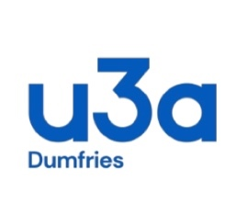
STANDING ORDER MANDATE
Name of Bank
Address
Please set up this standing order, cancelling any previous instruction regarding this recipient

Sorting Code | 80-11-60
Account Number | 00696091
Name of Account | u3a in Dumfries
Membership number
Amount (in figures) | £
Amount (in words)
Date of first payment | 5th January 2026
Frequency | Annually thereafter
Account to be debited
Name
Sorting Code
Account Number
Confirmation details
Name
Signature
Date

